140409

Calibrating Upper Camera

Intrinsic matrix

674.122 0 147.790

0 684.541 121.238

0 0 1

Distortion Matrix



Error 0.22

Distance z 56.5 cm

Besar line 28.2

D = 5.13967

Bottom camera (perlu di ulang)

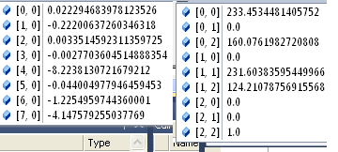

Diulang (lebih benar sepertinya)

